**Year 11 Physics**

**Electricity**

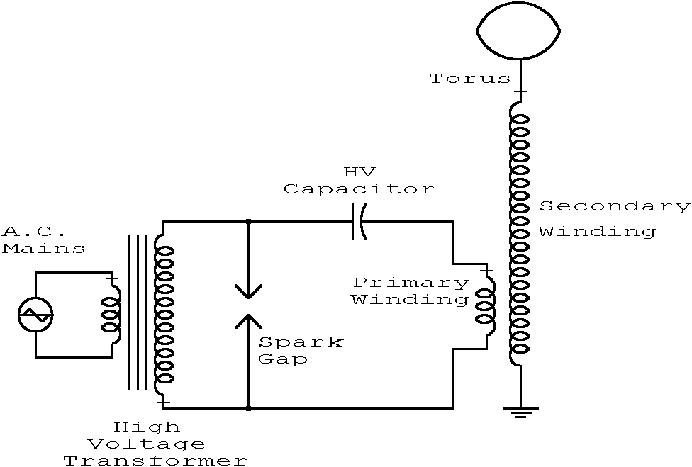

(bibliotecapleyades.net, n.d.)

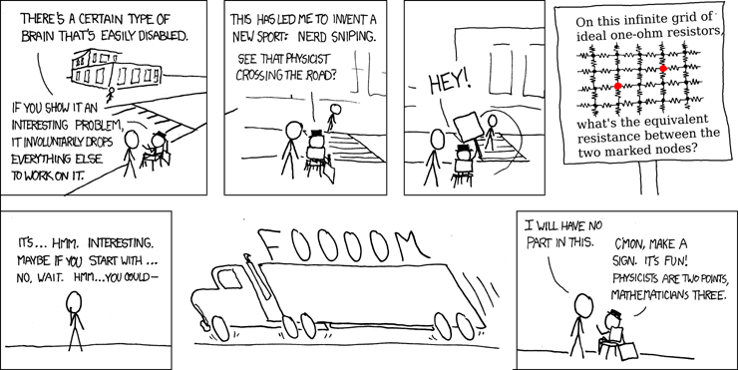

(Munroe, n.d.)

**Name:**

**SCSA ATAR Syllabus**

<https://senior-secondary.scsa.wa.edu.au/syllabus-and-support-materials/science/physics>

**Science Understanding**

* there are two types of charge that exert forces on each other
* electric current is carried by discrete charge carriers; charge is conserved at all points in an electrical circuit This includes applying the relationship
* energy is conserved in the energy transfers and transformations that occur in an electrical circuit
* the energy available to charges moving in an electrical circuit is measured using electric potential difference, which is defined as the change in potential energy per unit charge between two defined points in the circuit This includes applying the relationship
* energy is required to separate positive and negative charge carriers; charge separation produces an electrical potential difference that drives current in circuits
* power is the rate at which energy is transformed by a circuit component; power enables quantitative analysis of energy transformations in the circuit This includes applying the relationship
* resistance depends upon the nature and dimensions of a conductor
* resistance for ohmic and non-ohmic components is defined as the ratio of potential difference across the component to the current in the component This includes applying the relationship
* circuit analysis and design involve calculation of the potential difference across the current in, and the power supplied to, components in series, parallel, and series/parallel circuits This includes applying the relationships

series components,   
parallel components, V

* there is an inherent danger involved with the use of electricity that can be reduced by using various safety devices, including fuses, residual current devices (RCD), circuit breakers, earth wires and double insulation
* electrical circuits enable electrical energy to be transferred and transformed into a range of other useful forms of energy, including thermal and kinetic energy, and light

**Science as a Human Endeavour**

The supply of electricity to homes has had an enormous impact on society and the environment. An understanding of electrical circuits informs the design of effective safety devices for the safe operation of:

* lighting
* power points
* stoves
* other household electrical devices.

****Proposed timeline****

|  |  |  |  |  |  |
| --- | --- | --- | --- | --- | --- |
| **Wk** | **#** | **Topic** | **PowerPoint** | **STAWA Questions** | **Pearson Physics** |
| 8 | 1 | Static electricity |  |  |  |
| 8 | 2 | Van der graaf generator |  |  |  |
| 8 | 3 | Current |  |  |  |
| 8 | 4 | Voltage |  |  |  |
| 8 | 5 | Resistance |  |  |  |
| 9 | 1 | Energy |  |  |  |
| 9 | 2 | Power |  |  |  |
| 9 | 3 | **Task 4: Resistivity of a wire** |  |  |  |
| 9 | 4 | Circuits |  |  |  |
| 9 | 5 | Series circuits |  |  |  |
| 10 | 1 | Parallel circuits |  |  |  |
| 10 | 2 | Complex circuits |  |  |  |
| 10 | 3 | Year 11 Camp |  |  |  |
| 10 | 4 | Year 11 Camp |  |  |  |
| 10 | 5 | Good Friday |  |  |  |
| 1 | 1 | Anzac Day |  |  |  |
| 1 | 2 | Complex circuits |  |  |  |
| 1 | 3 | Complex circuits |  |  |  |
| 1 | 4 | Complex circuits |  |  |  |
| 1 | 5 | Energy sources |  |  |  |
| 2 | 1 | AC/DC |  |  |  |
| 2 | 2 | Effect on humans |  |  |  |
| 2 | 3 | Cross Country |  |  |  |
| 2 | 4 | Household electricity |  |  |  |
| 2 | 5 | Household electricity |  |  |  |
| 3 | 1 | Safety devices |  |  |  |
| 3 | 2 | Revision |  |  |  |
| 3 | 3 | Revision |  |  |  |
| 3 | 4 | **Task 5: Electricity topic test** |  |  |  |
| 3 | 5 | Nuclear |  |  |  |

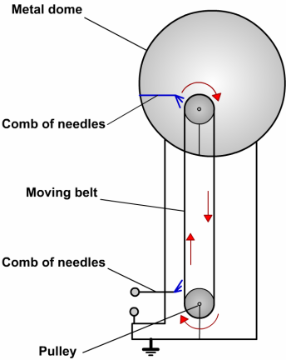****Static electricity****

* A stationary build-up of charge on the surface of an insulator
* Electric charge is measured in Coulombs (C)
* electrons
* Caused by an excess or deficit of electrons
* Created by rubbing two different insulators together; charging by friction
* Different materials attract electrons with different strengths, whichever material pulls more strongly on electrons will take electrons from the other, becoming negatively charged and leaving the other positively charged

****Electrostatic interactions****

* Like charges repel, opposite charges attract
* Charged objects weakly attract uncharged objects; induction

****Grounding****

* The ground functions as an infinite sink for/source of electrons to neutralise static charges
* A positively charged object can replenish its electrons from the ground
* A negatively charged object can disperse its excess electrons to the ground
* Connecting an object to the ground with a conductor prevents a static charge from building up on the object

****Van der Graaf generator****

* Comb at base rubs against belt stripping electrons and dispersing them to the earth
* Comb at top replenishes electrons on the belt, taking them from the metal dome leaving the dome positively charged
* As this continues, very large positive charges can build up on the metal dome



(Slide player, n.d.)

A plastic ruler is rubbed with a jumper.

1. Explain what happens referring to charges involved.
2. What will happen when the ruler is brought near small pieces of paper.
3. Explain why this happens
4. Explain how the van der Graaf works and the observations made with all the apparatus eg hair on end, spark, being zapped etc.
5. Draw the electric field diagrams for two like negatively charged points, opposite charged points, parallel plates.
6. An unknown metal wire has 0.5A current flowing through it when the voltage applied is 3V what is the resistance of the wire? Draw the circuit including a power pack, switch and the necessary meters. On circuit show direction of conventional current. What current actually flows?

****Current electricity****

* Flow of charge through a conductor (normally flow of electrons but can be ions)
* Current is measured in Amperes or Amps (A)
* 1 A is equivalent to 1C of charge flowing through a point in 1s
* 1 A electrons flowing through a point each second

1. Determine the charge that flows through a torch in 20 minutes while 300mA of current is flowing.
2. How many electrons passed through the torch filament in this time?

**Conventional current**

* The direction a positive charge would move
* Used by electrical engineers
* 1-way circuit components (diodes) have their circuit diagram symbols point in this direction
* Flow of positive charge from the positive terminal to the negative terminal

**Electron flow**

* Flow of electrons from the negative terminal to the positive terminal
* What occurs in metal wire circuits

****Voltage/Potential difference/Electromotive force****

* related concepts all measured in Volts
* Volts measure the amount of potential energy held by/lost by the electrons in a circuit
* Potential difference measures the amount of potential energy lost by electrons as they pass through a circuit component
* Electromotive force (emf) measures the amount of potential energy provided to electrons by a source of electrical energy, can also be referred to as potential difference (it is not a force at all)

The alternator of a car being driven at night with headlights on is producing 50A of current and an emf of 12 V.

1. How many coulombs of charge flow in 1 second?
2. How many joule so of energy does each coulomb obtain?
3. How many Joules of energy does the alternator produce each second?
4. Where does the energy go?

**Resistance**

* Measure of the difficulty of passing a current through a conductor, measured in Ohms (Ω)
* Analogous to friction
* Superconductors have a resistance of 0Ω, only at low temperatures (-70)

**Factors affecting resistance**

= resistivity, material specific (Ω m)

L = length (m)

A = cross-sectional area (m2)

* Also temperature dependent; low T = low R
* Running a current through a conductor causes it to heat up; the longer current flows the greater the resistance

A power cabling consists of 3 separate and insulated wires. Each wire is 1.00 mm in diameter. It’s resistivity is 1.72 x 10-5 ohm m.

1. Calculate the resistance of each wire if the cable is 25m long.
2. Determine the resistance of the same wire if the diameter was doubled.

**Ohm’s law**

* Only true for certain materials at constant T, these are known as ohmic conductors
* Key to most electricity calculations
* Lightbulbs are non-ohmic conductors but may behave as ohmic conductors at low voltages

**Ohm’s law graph**

* An applied voltage causes a current so voltage should plot on the x-axis
* However, if equation is rearranged to V=IR and voltage is plotted on the y-axis, then the gradient is the resistance which is convenient
* Here a gradient of 0.5 is observed so the graph shows the relationship between voltage and current for a 0.5 Ω resistor

**Non-ohmic conductors**

* A non-linear relationship is observed
* Resistance is current dependent
* Resistance can still be determined but only for a specified current
* Draw in a straight line tangential to the curve, find the gradient of the tangent
* Resistance at 8 A

1. Determine the resistance in a piece of resistance wire if the current is 250 mA when a PD of 6 V is applied.
2. Determine the current flowing through a 60 ohm resistor when the PD is 12V.
3. Determine the PD if 0.6A flows through a 350 ohm resistor.

****Electrical energy****

* Potential Difference is the work done per unit charge
* Recall that:
* By substitution can derive:

Electrons in a TV tube are accelerated through a potential difference of 2.00kV. Mass of e- = 9.11 x 10-31 kg

Calculate:

1. Work done on the electrons
2. KE of electrons
3. Final velocity of electrons assuming initially at rest.

How long does it take a piece of resistor wiring to heat 100mL of water from 200C to 900C if the potential difference across the resistor is 24V and the current flowing is 4.00 A. Assume no heat lost to the surroundings.

****Electrical power****

* Power is the rate at which work is done or energy is transformed
* Recall that:
* By substitution can derive:

A headlamp is rated 12 V and 5 A, what is its power?

Bulbs are rated: 2.8V, 0.27A and 4.2V, 0.18A

1. Which will be the brightest?
2. Could they be interchanged?

****Other derived equations for power****

* Use this eqn for heat released from appliance/wiring.
* Heating effect
* To gain more power must R be increased or decreased?
* Decrease R, so the current increases having an increase in power as is squared.

A car’s headlights are rated at 50.0W and operate on 12.0V. Calculate:

1. Current flowing in each headlight
2. Charge passing through each globe every second.
3. Total energy consumed by 2 headlights during a 2 hour night journey.

****Electric circuits****

* A circuit is a path where a current can flow
* If the flow is to be continuous, there can be no gaps in the path
* Introduce gaps in the form of switches, so we can control completing a circuit
* Most circuits have more than one device that we want to provide with electrical energy

****Circuit diagrams****

* Drawn using straight lines for wires, right angle corners
* Specific symbols for circuit components

****Component symbols****

****Power in circuits****

* Total power supplied to circuit = sum of power delivered to each appliance irrespective of how the appliances are connected (series or parallel)
* PT = P1 + P2 + P3 +…

****Series circuits****

* A single pathway through the circuit
* The current is the same everywhere in the circuit
* Voltage divides among the devices.
* Voltage drop across each device is IRdevice
* Total resistance is the sum of each individual resistance

****Measuring current****

* Measured with an ammeter, which is connected in series

****Parallel circuits****

* Two or more pathways through the circuit
* The voltage is the same across each branch
* Current divides among the pathways.
* Inverse of total resistance is the sum of the inverse of each individual resistance

****Measuring voltage****

* Measured with a voltmeter, connected in parallel around the device(s) being measured

****Complex circuits****

* Most circuits contain both series and parallel parts
* First step is normally to determine the total equivalent resistance so that the total current can be determined
* Ohm’s law is key
* Ignore the resistance of wires just as we ignore friction in motion

****Kirchoff’s laws****

First

* The sum of the electric currents into a junction = sum of currents leaving a junction : 2A + 3A = 5A

Second

* The total potential drop around a closed circuit must be equal to the total EMF in the circuit.

Two resistors of 10 and 20 ohm are connected in series with a 12V power pack.

1. Draw circuit
2. Find effective resistance.
3. Find total current and power.
4. Find current in each pathway.

Repeat with the two resistors in parallel.

1. Draw diagram of 12V source connected to R1 (2V on voltmeter) in series with 2 resistors (R3 = 30 ohm) in parallel. Ammeter in series part = 1.6A
2. Find resistance of R1 and R2
3. Find current in R2 and R3
4. Find voltage across R2 and R3
5. Find total resistance

****Sources: Cells and batteries****

* Emf = electromotive force = the potential difference across the source i.e. the energy gained per coulomb
* Chemical cells: chemical PE 🡪 EE
* A chemical reaction occurs at each electrode.
* Negative electrode – electrons given up to electrode.
* Positive electrode – electrons removed in reaction.

****Cells in series****

* Head to tail eg torch
* VT = V1 + V2 + V3
* I same

****Cells in parallel****

* Side by side + to + and – to –
* Current splits
* Emf of only one cell.
* Each cell only supplies fraction of current so it will last longer.
* Jumper leads – connect in parallel (+to+ and – to -) if connect + to – a short circuit is achieved and a huge current with sparking or fire occurs

****AC vs DC****

* AC = Alternating current
* The electrons oscillate backwards and forwards, passing the electrical energy onwards but they themselves don’t move around the circuit.

**Australian mains**

* Household mains power is 240V AC
* AC alternates between peak values of 340V and -340V but gives equivalent power as 240V DC.

**Direct current**

* Electrons flow in one direction only and they move around the circuit carrying the energy.
* DC is a steady voltage.

**Electric shocks**

* Electricity has 3 effects on the human body:
  + Electrolysis which produces toxins.
  + Heating – body offers high resistance.
  + Stimulation of nerves. Nerves use electrical impulses to send signals. Can make muscles contract and ‘not let go’ and can stop heart beat and turn it into a fibrillation (shivering)
* The quantity of current flowing through your body depends on:
* Your electrical resistance
  + - Dry = greater R, smaller I, (10-100 k ohm)
    - Sweaty/wet = less R, greater I (1 k ohm)
* Connections to make a circuit or grounded.
* The potential difference applied to your body by the source.
* Time of connection affects damage done.

**Dangers of AC vs DC**

* a high enough current will kill regardless
* AC may be more likely to stop your heart
* DC more likely to prevent muscles from letting go
* If a DC shock is survived may still die a few hours later
* DC electrolyses body fluids creating toxic products inside the body

|  |  |
| --- | --- |
| **Current (mA)** | **Effect on the body if flowing for 0.5s** |
| 1 | Threshold of feeling |
| 3 | Easily felt |
| 10 | Painful |
| 20 | Muscles paralysed – cannot let go |
| 50 | Severe shock |
| 90 | Breathing upset |
| 150 | Breathing very difficult |
| 200 | Death likely |
| 500 | Serious burning, breathing stops, death inevitable |

****Transmission of electricity****

* Ploss=I2R
* P=VI
* By transmitting power at high voltages it is possible to maintain the amount of power being transmitted but reduce the power loss by reducing the current

**Three pin plugs**

* Completing a circuit requires two wires
* Australian plugs sometimes have 3
* Generally only need the third for   
  devices with conductive housings

**Household circuits**

Active wire

Neutral wire

Earth wire

**Active wire:**

* Part of circuit
* Provides the push and pull on the electrons
* Rapidly alternates at 50Hz between roughly 340V and -340V
* Creates an equivalent voltage of roughly 240V DC

**Neutral wire:**

* Completes the circuit
* Is earthed so at 0V

**Earth wire:**

* Not part of the circuit
* Creates a path to earth for appliance with metal cases
* Safety feature
* Devices connected in parallel so they can be turned on and off independently

****Short circuit****

* Short circuit completes circuit bypassing any load
* R is greatly reduced
* I is greatly increased
* Causes heating of wires leading to fire

****Fuses****

* A significantly higher current than normal is typically caused by a fault of some sort e.g. short circuit
* Fuses prevent fires in such situations
* Fuses are normally functioning wire at normal currents
* If current is above safe level the fuse melts cutting the circuit
* Different fuses for different purposes, always use correct fuse

****Circuit breakers****

* Serves same purpose as fuse
* Cuts circuit when current in circuit is too high
* Not destroyed, no need to replace after tripping
* Switch thrown by electromagnet if current becomes too high

****Earth wire****

* If active wire inside a device comes lose and touches the housing, the housing becomes live, anyone touching it can be electrocuted, completing the circuit through their body to the ground
* Earth wire connects metal cases to the ground so if the case becomes live it immediately connects to the earth, causing a large current, throwing a circuit breaker or burning out a fuse

****Double insulation****

* Alternative to earth wire
* Make the case out of plastic
* The active wire is contained in a plastic sheath (1st layer of insulation)
* If the appliance case is also plastic (2nd layer of insulation) it is very difficult for a user to accidentally contact a live part connected to the active wire
* Such devices do not need a 3rd pin on their power plug

****Residual current devices (RCDs)****

* Compares current through active wire with current though neutral wire
* During normal operation should be identical
* If they are different there is most likely a fault (e.g. current flowing to ground through earth wire or a person)
* The two wires are wound to create opposing electromagnets, if one is greater switch is thrown
* Immediately (≈0.02s) cuts circuit

**Circuit Exercise**

1. Three resistors of 12 Ω, 16 Ω and 8 Ω are connected in series and a 12V potential difference is applied across the combination.
2. What is the total resistance?
3. What current flows?
4. What is the potential difference across the 8 Ω resistor?
5. A battery, supplying a potential difference of 12.0 V is connected to two resistors 5 Ω and 20 Ω connected in parallel.
6. What is the combined resistance?
7. What total current flows in the circuit?
8. What is the current in the 20 Ω resistor?
9. A toaster and a kettle connected in parallel have 240V mains potential difference applied across them. The current in the toaster is 2A and the current in the kettle is 5A. Calculate:
10. The resistance of the toaster
11. The resistance of the kettle
12. The total current flowing.
13. An 8 Ω resistor and a 2 Ω resistor are connected in parallel. This combination is connected in series with a 2.4 Ω resistor and a 6 V battery.
14. What is the total resistance?
15. What current flows in the 2.4 Ω resistor?
16. What is the potential difference across the parallel combination?
17. What current flows in the 8 Ω resistor?
18. Three cells, each with an emf of 2.2V are in series. The battery is connected in series with a switch S, an ammeter, a resistor of 1.8 Ω and a combination of two parallel connected resistors of 2 Ω and 3 Ω respectively. Voltmeters V1 and V2 are connected across the battery terminals and across the parallel resistors respectively.
19. Draw the circuit diagram.
20. What are the readings on A, V1 and V2 when S is open?
21. Determine the equivalent resistance of the parallel combination of resistors.
22. What will be the readings on A, V1 and V2 when S is closed?
23. How much energy is consumed by the 1.8 Ω resistor in 1 minute?
24. In the circuit below the 12 V battery and meters have negligible resistance. Voltmeter V1 reads 9V. R is a resistor of unknown resistance.

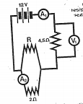

Calculate:

1. The reading on ammeter A1.
2. The reading on ammeter A2.
3. The resistance of R.
4. The energy transferred in the 4.5 Ω resistor in 1 minute.
5. A lamp operates on a 100 V supply and draws a current of 0.50 A. What resistor must be placed in series if it is to be used on a 230 V supply.
6. Calculate the current in the 2 ohm resistor.

1.0 ohm



15.0 V

3.0 ohm

2.0 ohm

1. The three resistors of 4.0 Ω, 8.0 Ω and 40.0 Ω are connected in parallel. The 4.0 Ω resistor carries a current of 2A. Calculate:
2. The combined resistance
3. The potential difference across the parallel branch.
4. 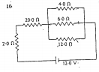The current in the 8.0 Ω and 40.0 Ω resistors.

4.0 ohm

6.0 ohm ohmohm

20.0 ohm

2.0 ohm

12.0 ohm

12.0 V

1. The diagram shows resistances joined in parallel and series.
2. What is the equivalent resistance of the circuit?
3. What current flows through the 20 Ω resistor?
4. What is the potential difference across the 2 Ω resistor?
5. What is the potential difference across the 4.0 Ω resistor?
6. What is the current flowing through the 4.0 Ω resistor?

**Answers:**

1. a) 36 Ω b) 0.33A c) 2.67V
2. a) 4 Ω b) 3A c) 0.6A
3. a) 120 Ω b) 48 Ω c) 7A
4. a) 4 Ω b) 1.5 Ω c) 2.4V d) 0.3 A
5. b) 0A 6.6V 0V c) 1.2 ohm d) 2.2A, 6.6 V , 2.64V A e) 523J
6. a) 2A b) 1.5A c0 6 Ω d) 1080 J
7. 260 Ω
8. 5A
9. a) 2.5 Ω b) 8V c) 1A and 0.2A
10. a) 24 Ω b) 0.5A c) 1V d) 1V e) 0.25A
11. a) VAB 12V b) IAB = 0.3 A c) I = 0.2A
12. R = 8 ohm.

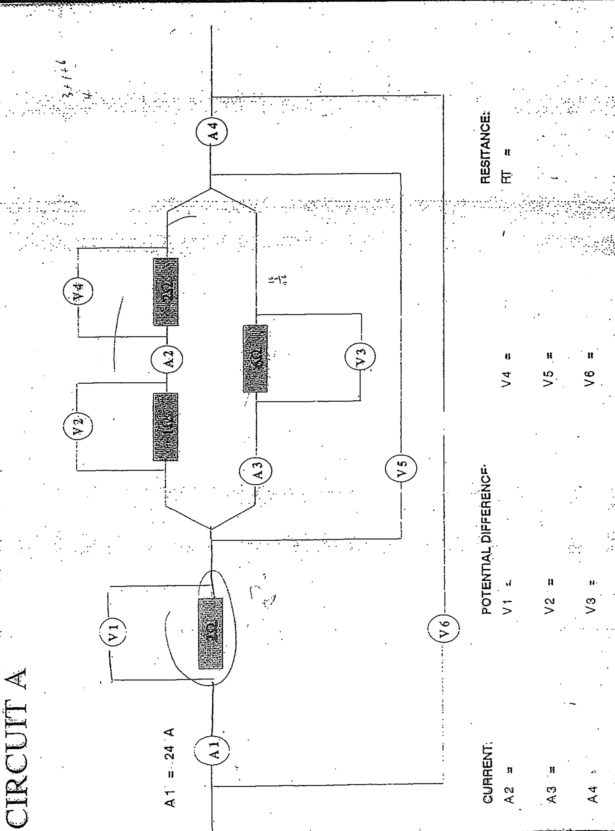

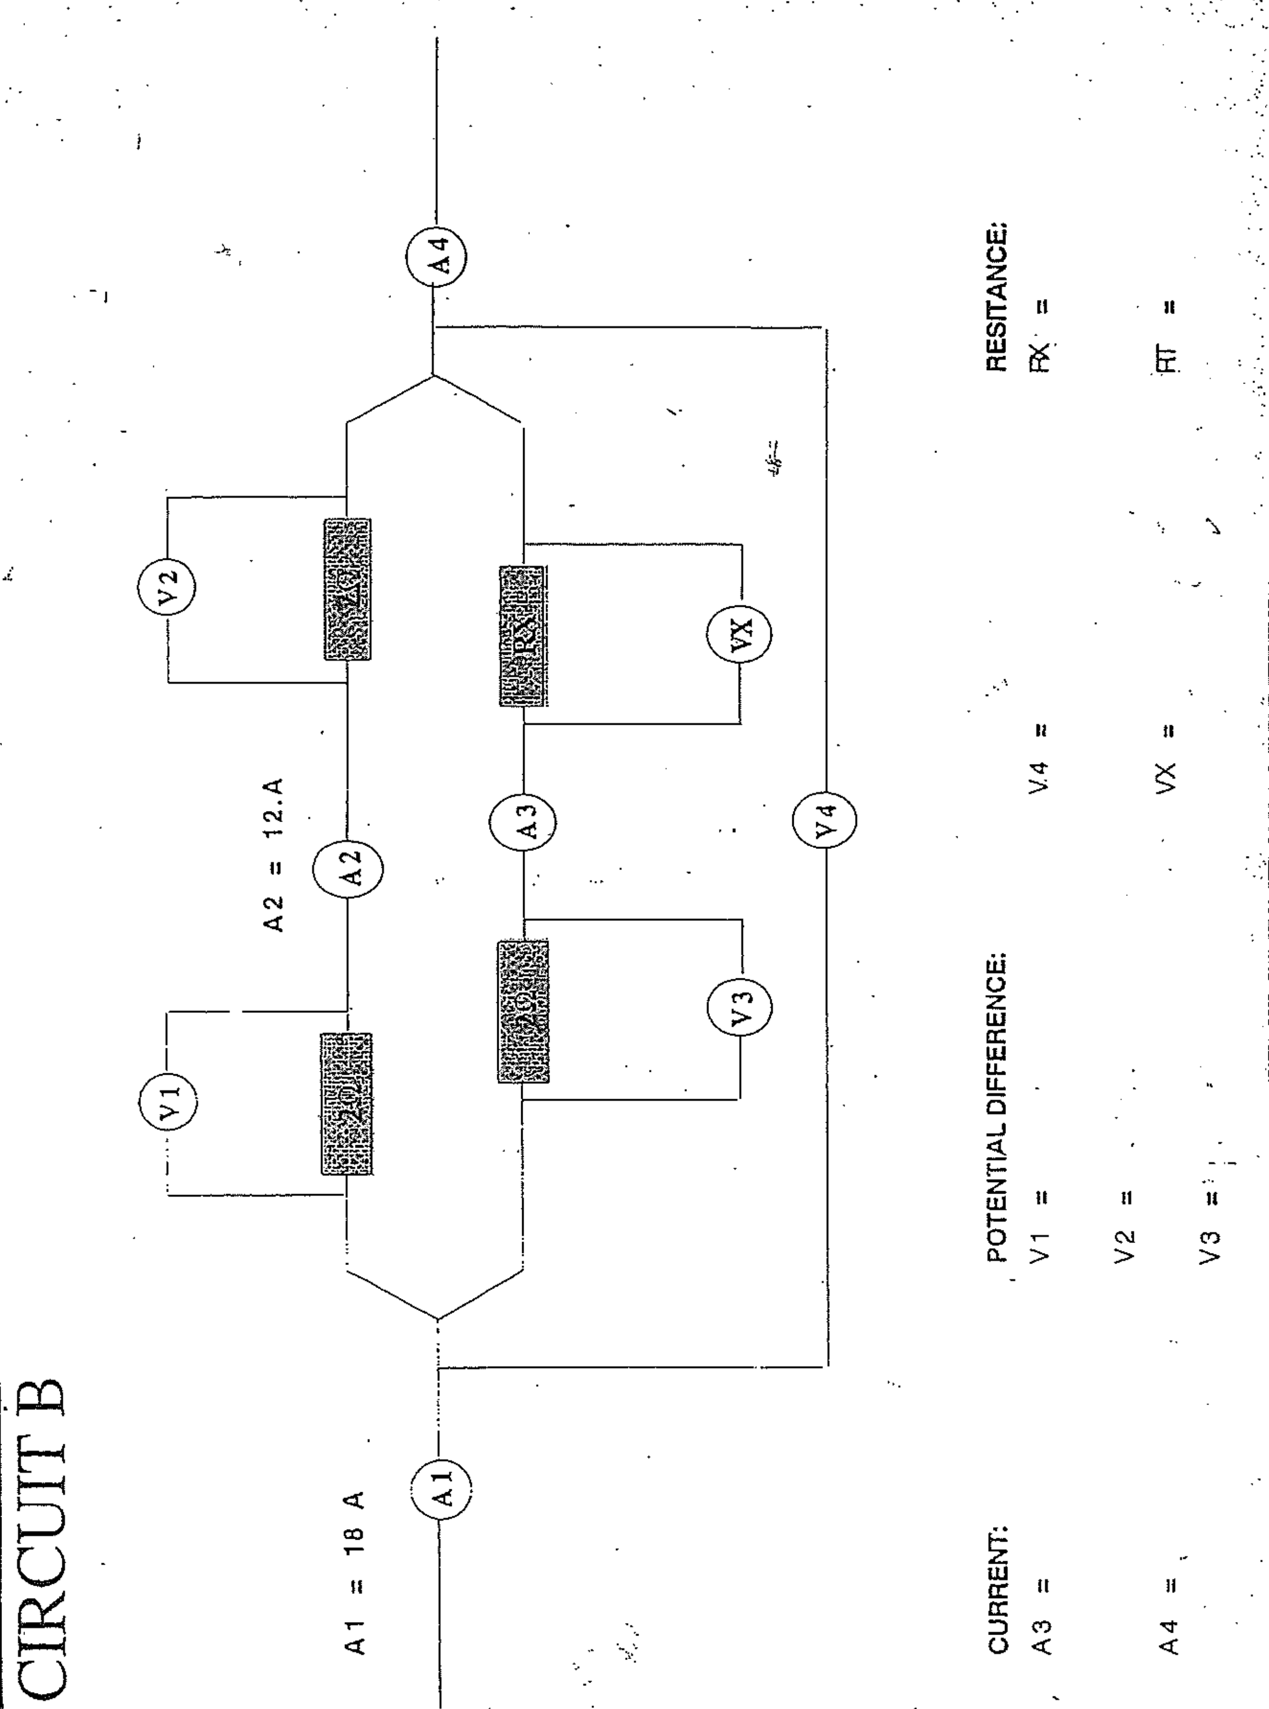

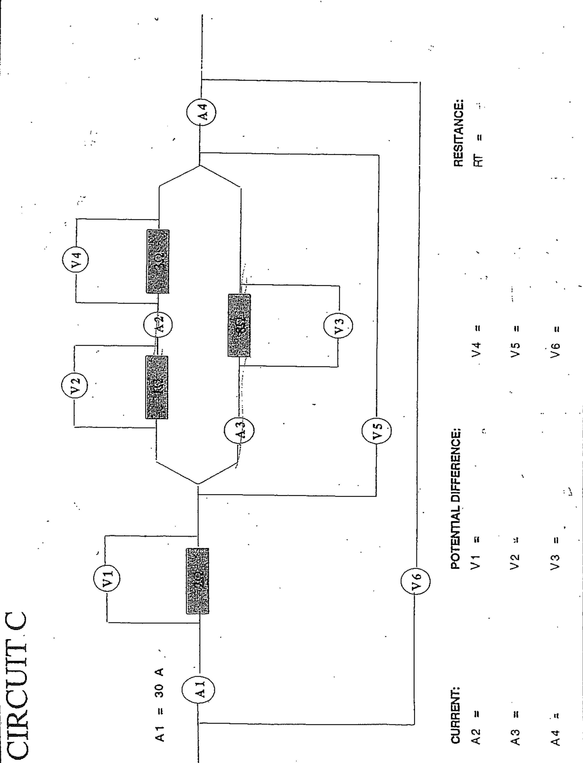

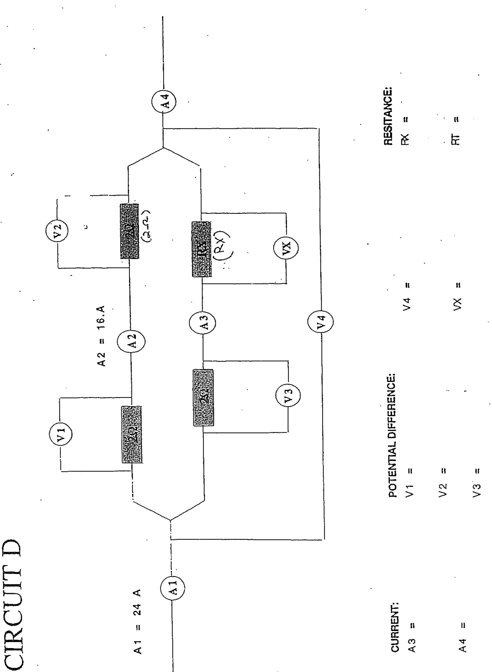

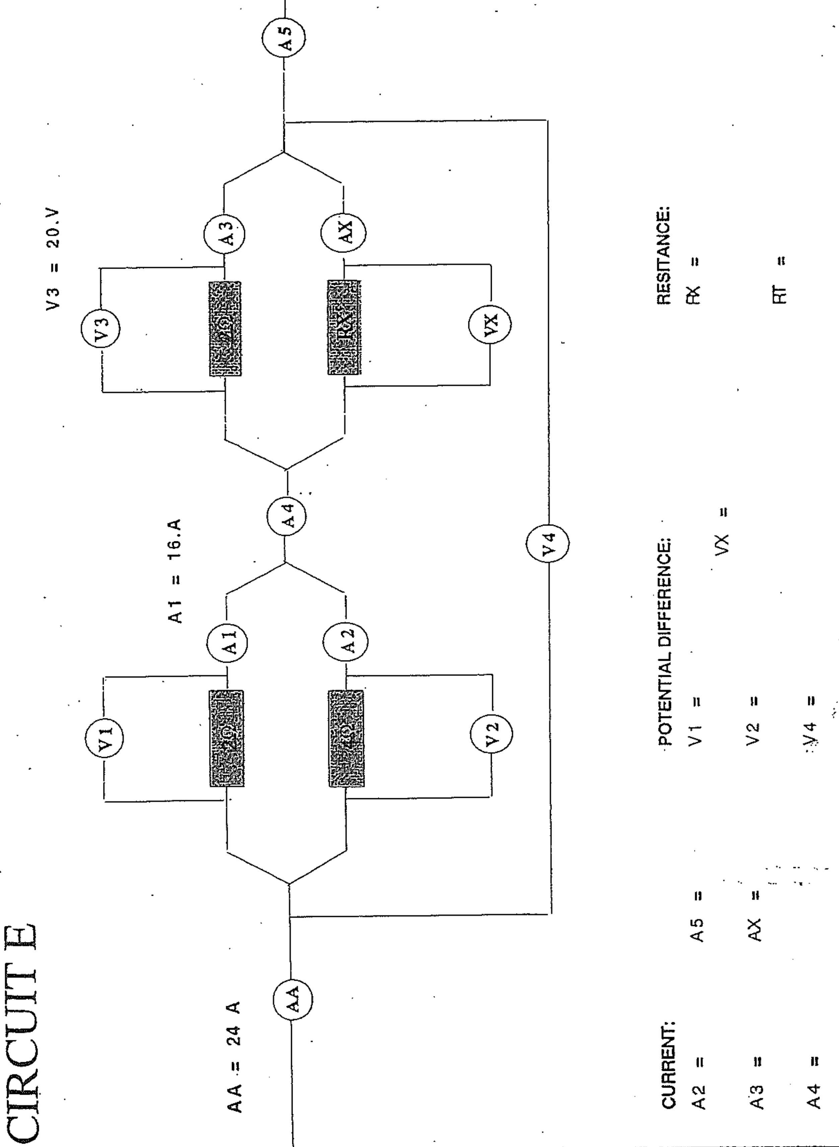

# Solutions

# Circuit A

A2=16A V1=48V V4=32V RT=4Ω

A3=8A V2=16V V5=48V

A4=24A V3=48V V6=96V

**Circuit B**

A3=6A V1=24V V4=48V RX=6Ω

A4=18A V2=24V VX=36V RT=2.67Ω

V3=12V

**Circuit C**

A2=20A V1=60V V4=60V RT=4.67Ω

A3=10A V2=20V V5=80V

A4=30A V3=80V V6=140V

**Circuit D**

A3=8A V1=32V V4=64V RX=6Ω

A4=24A V2=32V VX=48V RT=2.67Ω

V3=16V

**Circuit E**

A2=8A A5=24A V1=32V VX=20V RX=1.43Ω

A3=10A AX=14A V2=32V RT=2.17Ω

A4=24A V4=52V

# References

(n.d.). Retrieved from Slide player: http://slideplayer.com/slide/4442442/

*bibliotecapleyades.net*. (n.d.). Retrieved from Tesla coil: http://www.bibliotecapleyades.net/imagenes_tesla/tesla17_02.gif

*Thermometer Clip Art - Image #8708*. (n.d.). Retrieved from Clip art: http://cliparting.com/free-thermometer-clip-art-8708/